CAS PY 106

In-Class Note 12

1. Comparing two light bulbs - series
2. 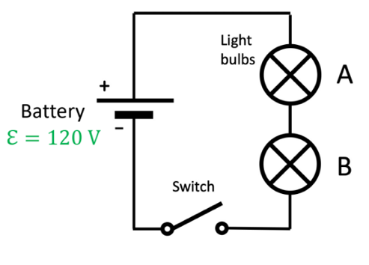
3. Light bulb A has resistance of 360 Ohms, light bulb B has resistance of 140 Ohms
4. Light bulb that shines brighter will dissipate more power in the form of heat
5. Equivalent resistance of circuit: 360 + 140 = 500 Ohms
6. Current passing through each bulb: I40= 0.24, I100=0.24
7. Voltage across each bulb: V40=86.4V, V100=33.6V
8. Power dissipated in each bulb: P40=20.736W, P100=8.064W
9. The light bulb that had higher resistance dissipate more power, leading to brighter light bulb
10. Comparing two light bulbs – parallel
11. 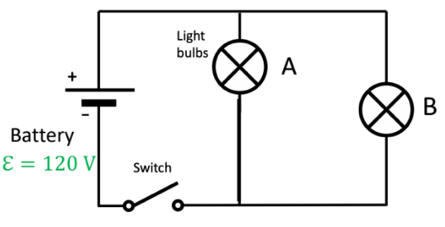
12. Light bulb A has resistance of 360 Ohms, light bulb B has resistance of 140 Ohms
13. Light bulb that shines brighter will dissipate more power in the form of heat
14. Equivalent resistance of circuit: 1/ (1/360+1/140) = 100.8 Ohms
15. Current passing through each bulb: I40= 0.33, I100=0.857
16. Voltage across each bulb: V40=120V, V100=120V
17. Power dissipated in each bulb: P40=39.6W, P100=102.84W
18. The light bulb that had lower resistance dissipate more power, leading to brighter light bulb